Multi-container Pod
A Multi-Container Pod is a Kubernetes Pod that contains more than one container, all running inside the same Pod and sharing:
- Same network namespace (same IP & ports)
- Same storage volumes
- Same lifecycle (start/stop together)
These containers are tightly coupled and work together as a single logical unit.
----------------------------------------------------------------------------------------------------------------
Creating multi-container pod, first we have to create a file,
And add the container details and ports as given below,
apiVersion: v1
kind: Pod
metadata:
name: multicontainer-pod
spec:
containers:
# NGINX Container
- name: nginx-container
image: nginx:latest
ports:
- containerPort: 80
hostPort: 8080

# Tomcat Container
- name: tomcat-container
image: tomcat:9.0-jdk11-openjdk
ports:
- containerPort: 8080
hostPort: 8081

# MySQL Container
- name: mysql-container
image: mysql

env:
- name: MYSQL_ROOT_PASSWORD
value: rootpass
ports:
- containerPort: 3306
hostPort: 3306
And check the given details,
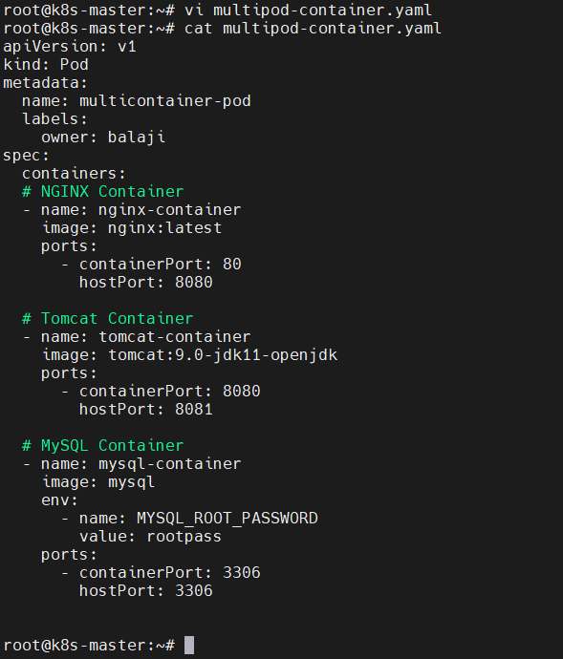
Then create the multi-container pod as given below,

Then check the container details in the given below,
